IWF MMS solar wind density product quick reference guide

The IWF solar wind density product gives a measurement of the electron density which is derived from the spacecraft potential. This document is meant to be a quick reference guide and not a detailed description of the data. For a more rigorous description of the data product the reader is referred to (insert citation).

Calibration

Detailed discussions of the calibration procedures can be obtained in many different references (e.g.). This essentially involves deriving the photocurve (variation of the photoelectron current with the spacecraft potential) where the photoelectron current is assumed to be equal to the electron thermal current Ie=Iph. The electron thermal current for a Maxwellian velocity distribution function is given by:
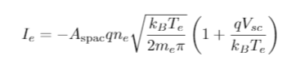 (1)

The photoelectron current can be expressed as:

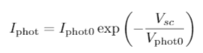 (2)

By equating Eq 1 and 2 and rearranging for the electron density we obtain the equation.

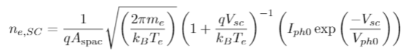(3)

To obtain the photoelectron parameters in Equation 2 and 3 the thermal current is fitted to the spacecraft potential. Examples of the photocurve are shown in Fig 1. Finally the measured mean electron temperature is used and n_e from the spacecraft potential can be estimated from Eq 3. It should be noted that changes in T_e can affect the spacecraft potential. But as the thermal current is proportional to n_e and the square root of T_e the fluctuations in the density will dominate.

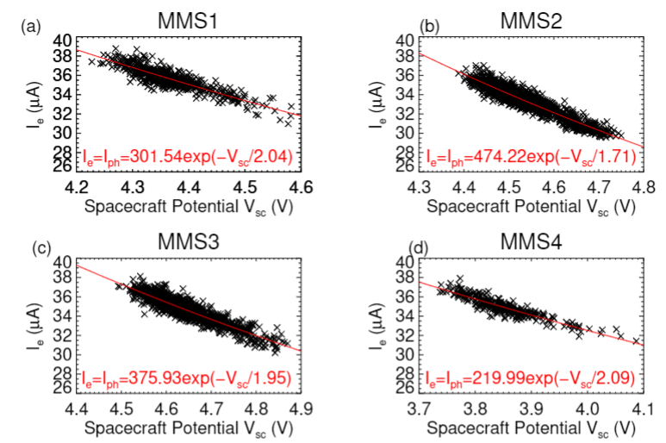
Figure 1: Photocurves for the MMS spacecraft

Spin removal
As the spacecraft spins the illuminated area of the spacecraft changes, resulting in changes in the spacecraft potential and in turn the electron density. This is removed by binning the data as a function of the spacecraft phase angle and then fitting a model to the median points for each angle bin. The model is then subtracted from the potential. An example of the spin relation is given in Figure 2. Further details can be found in (citation).
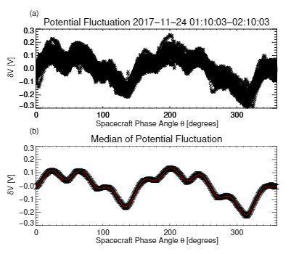Figure 2: Spin variation of the potential

Caveats

The majority of the data sets come from the long intervals of solar wind burst mode sampled by MMS. There are a few things to consider when using this data set.
- It is not guaranteed that these long intervals are devout of brief excursions into the foreshock.
- There may be times when the electric field varies significantly which causes the potential (and consequently the density estimation) to vary due to the electric field rather than density fluctuations.
- Dust strikes can cause large perturbations in the density i.e. fluctuations of several particles per cc in on ms timescales. Examples are shown in Fig 3.
- Due to a probe failure on MMS4 their potential is not as well estimated and the variance in the density at MMS4 is larger than at the other four spacecraft. Care should be taken when comparing the other spacecraft to MMS4.
- You should always compare to the FPI-DES data as sometimes the absolute value may be different between measurements. This may be different between different FPI measurements and different SC potential measurements and may be different between spacecraft.

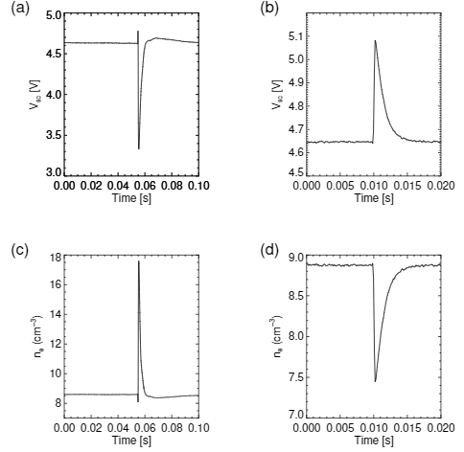Figure 3: Examples of a dust strike and an inverted signature

Reading the data

Data are provided in two different formats .sav and ascii
the .sav files can be opened in IDL using the restore command

restore, filename=’filename.sav’

The keyword /verbose to get the variable names. The variables should include the spedas time, a time string and the derived electron density.

If you have any questions or encounter any problems with the data you can contact Owen Roberts owen.roberts at oeaw.ac.at

