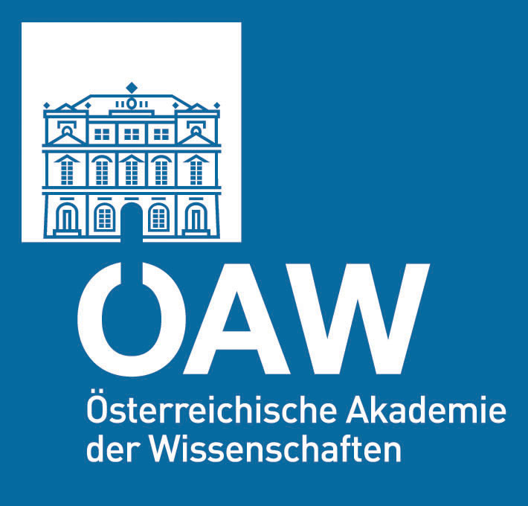
APPLICATION FOR FUNDING
OF A RESEARCH PROJECT WITHIN THE AUSTRIAN ACADEMY OF SCIENCES RESEARCH PROGRAMM
EARTH SYSTEM SCIENCES (ESS)

INTERNATIONALE
FORSCHUNGSPROGRAMME

Project type:
Standard project |  | Specific project for
 |  | Man and Biosphere (MAB)
Pilot project |  | International Geoscience Programme (IGCP)
 |  | Long-term socio-economic and ecosystem research (LTSER)

Year: | First application |  | Consecutive application

PROJECT TITLE

RUNNING TITLE AND/OR ACRONYM

PRINCIPAL INVESTIGATOR (Name, Address, Telephone, Fax, Email, WWW)

PROJECT MANAGER (Name, Address, Telephone, Fax, Email, WWW)

DURATION OF PROJECT: Year(s) or Months
REQUESTED BUDGET: Total: €
OTHER SOURCES OF FUNDING: no yes (if yes, please specify funding agency and sum)

CONNECTION TO OTHER RESEARCH PROGRAMMES/PROJECTS:

PLACE AND DATE | SIGNATURE
PROJECT ABSTRACT (in English)
*The field is limited to 4320 characters (Font size Arial 10,5).

KURZBESCHREIBUNG MIT TITEL (in Deutsch)
*The field is limited to 4320 characters (Font size Arial 10,5).

SUMMARY TO BE PRESENTED AT THE ÖAW WEBPAGE (in English)
*The field is limited to 2400 characters (Font size Arial 10,5).

KURZFASSUNG FÜR DIE ÖAW HOMEPAGE (in Deutsch)
*The field is limited to 2400 characters (Font size Arial 10,5).

ITEMIZATION OF REQUESTED FUNDING FOR FULL DURATION OF THE PROJECT

Personnel Description (Names, Status, Duration) | Costs (€)
(1) Subtotal “Personnel”:
Materials and Supplies
Equipment (Description, Purpose):

Expendables:

Travel Costs:

Other Expenses (Description):

(2) Subtotal “Materials and Supplies”
TOTAL COSTS (Sum of 1 and 2):
PROJECT DESCRIPTION

The scientific project description must address the following points:

1) Background and scientific aspects
2) Objectives
3) Aims for total duration of the project
5) Work plan and time plan (including methods) for total duration of the project
6) Deliverables (including planned strategies for dissemination of results)
7) Linkages to international research programmes/networks/cooperations (e.g. IGCP, IHDP, ISCAR, EU)
8) Scientific qualification of scientific personnel (CV`s, publication lists)
9) List of literature relevant to the project (for consecutive submission: list of publications published from results obtained in the previous project year(s)).

Please note that the project description must not exceed 20 pages including figures and tables!

Checklist for the complete application

 The entire application must be in English (unless previously agreed with the ÖAW).

 The complete application containing the application form and the scientific procect description should be submitted in both printed (including original signature of the applicant) and electronic versions (PDF or Word for Windows format; files may not exceed 5 MB in size). If the electronic file contains the original signature of the applicant submission of a hard copy is not necessary.

 The application must be sent as one file (no supplements!).

 Submission of a list of referees is optional.

